Assignment 6: Using BERT, DistilBert and RoBERTa
for NLP Classification
CSC 492/592: Large Language Models

Background

In this assignment, we will experiment with a pre-trained BERT model for NLP classification problems. We will also explore related models such as DistilBERT and RoBERTA.
BERT (Bidirectional Encoder based Representation for Transformers) is an encoder base transformer model that was developed by Googled in 2018. It was trained on approximately ~2.5-billion-word Wikipedia documents and ~800-million-word Google Books Corpus.

Due to its specialized training which involves bidirectional Masked Language Modeling (MLM) and Next Sentence prediction (NSP), it performs extremely well on NLP classification problems. MLM masks out a random word (replaces it with the [MASK] token) and the model learns to predict the missing word. In NSP, two sentences (which may or may not be in proper order) are fed to the model. The model learns to predict if the second sentence follows the first or not.
BERT is released in two configurations, BERT-Base and BERT-Large as shown below:

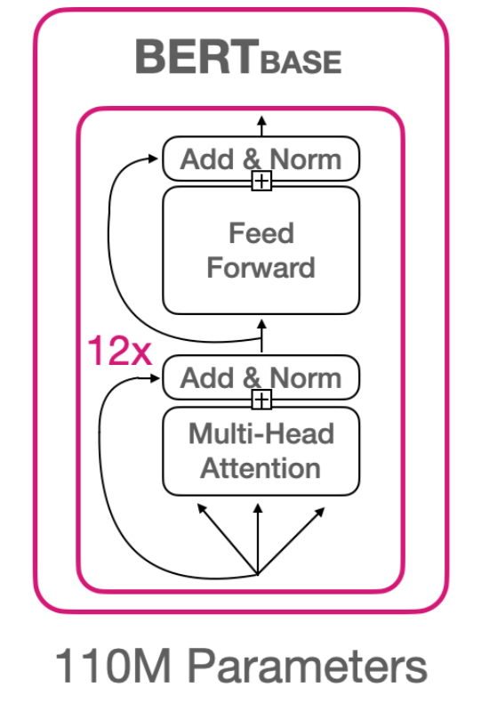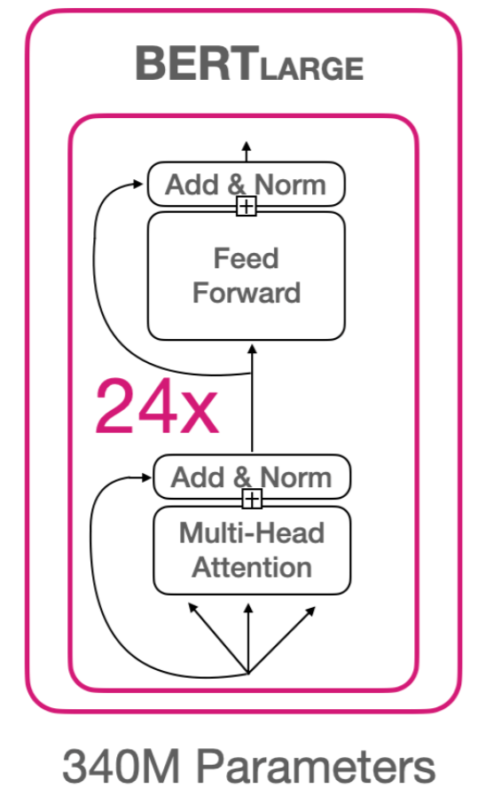

We will experiment with BERT-base. It has a sequence length of 512 tokens, and an embedding size of 768. BERT-base uses the Wordpiece tokenization algorithm which is similar to the BPE tokenization algorithm discussed in the class.

The dictionary for BERT comes in two flavors, cased and uncased where each character is converted to lower case. The dictionary size for BERT-base-uncased is 30,522. For cased, it is 28,997. If a word is encountered that is not part of the dictionary, it is represented as [UNK] token. BERT adds a special [CLS] token in the beginning of an input sequence, CLS vector captures the meaning of the entire document as it passes through different transformer layers and can be used in the classification process after the last layer. We will use BERT to experiment with multi-class classification on the emotion dataset. This dataset has six classes.

Follow the step-by-step guide and answer each of the exercise questions.

Step by Step Guide

Part 1: BERT and the Emotion Dataset

Step 0: Install the datasets library (https://pypi.org/project/datasets/): pip install datasets

Step 1: Create a new Python application called BERTMulticlassClassification. Add a file called “Utils.py” with the following code in it. This code contains the code for tokenizing the text, and preparing train, validation and test dataloaders.

from datasets import load_dataset
emotion = load_dataset('emotion')
from transformers import BertTokenizer
from transformers import AutoTokenizer
import torch
from torch.utils.data import TensorDataset, DataLoader, RandomSampler, SequentialSampler

# The emotion dataset consists of three sets: train, validation, and test
# It has six kinds of emotion: sadness, joy, love, anger, fear, and surprise

def encode(docs, tokenizer):
'''
This function takes list of texts and returns input_ids and attention_mask of texts
'''
encoded_dict = tokenizer.batch_encode_plus(docs, add_special_tokens=True, max_length=128, padding='max_length', return_attention_mask=True, truncation=True, return_tensors='pt')
input_ids = encoded_dict['input_ids']
attention_masks = encoded_dict['attention_mask']
return input_ids, attention_masks

def get_trainvalidtest_loaders(BATCH_SIZE=16):
label_names = emotion["train"].features['label'].names
print(label_names)
emotion.set_format(type="pandas")
train_df = emotion['train'][:]
valid_df = emotion['validation'][:]
test_df = emotion['test'][:]
print(train_df.head())
print("---------counts before taking subset of data------------")
print(train_df['label'].value_counts())
print(valid_df['label'].value_counts())
print(test_df['label'].value_counts())
print("---------------------------------------------------------")
num_train = 500 # number of data items to use for training
num_validate = 80
num_test = 65
train_df = train_df.groupby('label').apply(lambda x: x.sample(num_train)).reset_index(drop=True)
valid_df = valid_df.groupby('label').apply(lambda x: x.sample(num_validate)).reset_index(drop=True)
test_df = test_df.groupby('label').apply(lambda x: x.sample(num_test)).reset_index(drop=True)
print("---------counts after taking subset of data------------")
print(train_df['label'].value_counts())
print(valid_df['label'].value_counts())
print(test_df['label'].value_counts())
print("---------------------------------------------------------")

# use BERT pretrained tokenizer
tokenizer = BertTokenizer.from_pretrained("bert-base-cased", do_lower_case=True)
print(tokenizer)
train_list = train_df['text'].values.tolist()
train_input_ids, train_att_masks = encode(train_list, tokenizer)
valid_input_ids, valid_att_masks = encode(valid_df['text'].values.tolist(), tokenizer)
test_input_ids, test_att_masks = encode(test_df['text'].values.tolist(), tokenizer)
num_check = 5
print(train_list[num_check])
print(train_input_ids[num_check])
print(train_att_masks[num_check])

# get the labels
train_y = torch.LongTensor(train_df['label'].values.tolist())
valid_y = torch.LongTensor(valid_df['label'].values.tolist())
test_y = torch.LongTensor(test_df['label'].values.tolist())
print(train_y.size(),valid_y.size(),test_y.size())

train_dataset = TensorDataset(train_input_ids, train_att_masks, train_y)
train_sampler = RandomSampler(train_dataset)
train_dataloader = DataLoader(train_dataset, sampler=train_sampler, batch_size=BATCH_SIZE)

valid_dataset = TensorDataset(valid_input_ids, valid_att_masks, valid_y)
valid_sampler = SequentialSampler(valid_dataset)
valid_dataloader = DataLoader(valid_dataset, sampler=valid_sampler, batch_size=BATCH_SIZE)

test_dataset = TensorDataset(test_input_ids, test_att_masks, test_y)
test_sampler = SequentialSampler(test_dataset)
test_dataloader = DataLoader(test_dataset, sampler=test_sampler, batch_size=BATCH_SIZE)
return train_dataloader, valid_dataloader, test_dataloader, train_df, valid_df, label_names

Step 2: Add a file called “MyBertModel.py” with the following code in it:

import torch
from torch import nn
from transformers import BertModel
from transformers import AutoModel

# classifier to be attached to last part of BERT
class Classifier(torch.nn.Module):
def __init__(self, bert_embedding, num_classes):
super(Classifier, self).__init__()
hidden_layer = 100
self.fc1 = torch.nn.Linear(bert_embedding, hidden_layer)
self.dropout1 = torch.nn.Dropout(0.2)
self.act1 = torch.nn.ReLU(hidden_layer) # ReLU
self.fc2 = torch.nn.Linear(hidden_layer, num_classes)
self.softmax = torch.nn.Softmax(dim=1)

def forward(self, encoded_input):
out1 = self.dropout1(self.fc1(encoded_input))
out2 = self.act1(out1)
logits = self.fc2(out2)
probabilities = self.softmax(logits)
return probabilities

class MyBertModel(nn.Module): # pretrained BERT + our own classifier
def __init__(self, dropout_probability=0.2, use_dropout=True):
super(MyBertModel, self).__init__()
self.bert_model = AutoModel.from_pretrained('bert-base-cased')
print(self.bert_model)
self.use_dropout = use_dropout

hidden_size = self.bert_model.config.hidden_size
num_classes = 6
self.classifier = Classifier(hidden_size, num_classes)

# Freeze some BERT layers ---------------
#modules = [self.bert_model.embeddings, self.bert_model.encoder.layer[:5]]
# first 5 layers will not be finetuned
#for module in modules:
# for param in module.parameters():
# param.requires_grad = False

def forward(self, input_id, mask):
hs, pooled_output = self.bert_model( input_ids= input_id, attention_mask=mask, return_dict=False )

# classifier for BERT model's output
out = self.classifier(pooled_output)
return out

Step 3: Type the following code in the main file, “BertMulticlassClassification.py”.

import Utils
import sys
from torch.optim import AdamW
from transformers import get_linear_schedule_with_warmup
import torch
from MyBertModel import MyBertModel
from torch.nn.utils import clip_grad_norm_
from torch import nn
from tqdm import tqdm
import numpy as np
import math
from sklearn.metrics import classification_report
from sklearn.metrics import ConfusionMatrixDisplay, confusion_matrix
import matplotlib.pyplot as plt

def plot_confusion_matrix(y_preds, y_true, labels=None):
cm = confusion_matrix(y_true, y_preds, normalize="true")
fig, ax = plt.subplots(figsize=(6, 6))
disp = ConfusionMatrixDisplay(confusion_matrix=cm, display_labels=labels)
disp.plot(cmap="Blues", values_format=".2f", ax=ax, colorbar=False)
plt.title("Normalized confusion matrix")
plt.show()

def main():
device = torch.device("cuda" if torch.cuda.is_available() else "cpu")
train_dataloader, valid_dataloader, test_dataloader, train_df, valid_df, label_names = Utils.get_trainvalidtest_loaders()

model = MyBertModel().to(device) # loads pretrained BERT model and attaches classifier to it

EPOCHS = 15
LEARNING_RATE = 3e-6
BATCH_SIZE = 16
criterion = nn.CrossEntropyLoss()
optimizer = AdamW(model.parameters(), lr=LEARNING_RATE)
scheduler = get_linear_schedule_with_warmup(optimizer, num_warmup_steps=0,
num_training_steps=len(train_dataloader)*EPOCHS )

train_loss_per_epoch = []
val_loss_per_epoch = []

for epoch_num in range(EPOCHS):
print('Epoch: ', epoch_num + 1)
model.train()
train_loss = 0
for step_num, batch_data in enumerate(tqdm(train_dataloader,desc='Training')):
input_ids, att_mask, labels = [data.to(device) for data in batch_data]
output = model(input_id = input_ids.to(device), mask=att_mask.to(device))

loss = criterion(output, labels.to('cuda'))
train_loss += loss.item()

model.zero_grad()
loss.backward()
del loss

clip_grad_norm_(parameters=model.parameters(), max_norm=1.0)
optimizer.step()
scheduler.step()
train_loss_per_epoch.append(train_loss / (step_num + 1))

model.eval() # ------------validation------------
valid_loss = 0
valid_pred = []
with torch.no_grad():
for step_num_e, batch_data in enumerate(tqdm(valid_dataloader,desc='Validation')):
input_ids, att_mask, labels = [data.to(device) for data in batch_data]
output = model(input_id = input_ids.to(device), mask=att_mask.to(device))
loss = criterion(output, labels.to('cuda'))
valid_loss += loss.item()
valid_pred.append(np.argmax(output.cpu().detach().numpy(),axis=-1))

val_loss_per_epoch.append(valid_loss / (step_num_e + 1))
valid_pred = np.concatenate(valid_pred)

print("{0}/{1} train loss: {2} ".format(step_num+1, math.ceil(len(train_df) / BATCH_SIZE), train_loss / (step_num + 1)))
print("{0}/{1} val loss: {2} ".format(step_num_e+1, math.ceil(len(valid_df) / BATCH_SIZE), valid_loss / (step_num_e + 1)))

from matplotlib import pyplot as plt
epochs = range(1, EPOCHS +1 )
fig, ax = plt.subplots()
ax.plot(epochs,train_loss_per_epoch,label ='training loss')
ax.plot(epochs, val_loss_per_epoch, label = 'validation loss' )
ax.set_title('Training and Validation loss')
ax.set_xlabel('Epochs')
ax.set_ylabel('Loss')
ax.legend()
plt.show()

print('classifiation report')
print(classification_report(valid_pred, valid_df['label'].to_numpy(), target_names=label_names))
plot_confusion_matrix(valid_pred,valid_df['label'].to_numpy(),labels=label_names)

if __name__ == "__main__":
sys.exit(int(main() or 0))

Exercise 1: Record the output of your code (training and validation loss graph) and the confusion matrix. For this type of fine-tuning, was only the classifier parameters updated, or were all the parameters in the model updated?

Step 4: Uncomment the section in the “MyBertModel.py” as shown below:

# Freeze some BERT layers ---------------
#modules = [self.bert_model.embeddings, self.bert_model.encoder.layer[:5]]
# first 5 layers will not be finetuned
#for module in modules:
# for param in module.parameters():
# param.requires_grad = False

Uncommenting the above code freezes the first layers in BERT while the remaining layers are fine-tuned.

Exercise 2: Record the output of your code (training and validation loss graph) and the confusion matrix. For the Emotion dataset, which type of fine-tuning did better, the fine-tuning in exercise 1, or the type of fine-tuning that freezes certain layers?

Part 2: NLP Classification Using DistilBert

The DistilBERT model is a distilled version of BERT. It is smaller and faster, trained by distilling BERT base. It has 40% less parameters than google-Bert/Bert-base-uncased, executes 60% faster while preserving over 95% of BERT’s performances on most benchmarks. We will try DistilBert on the emotion dataset and see how it compares with the Bert-base.

Step 1: To use DistilBert, the typical code for creating the tokenizer and the model is:

tokenizer = AutoTokenizer.from_pretrained('distilbert/distilbert-base-cased')
model = AutoModel.from_pretrained("distilbert/distilbert-base-cased")

Modify the “Utils.py” to use the DistilBert tokenizer by commenting the tokenizer line and adding the line for DistilBert as shown below:

#use BERT pretrained tokenizer
#tokenizer = BertTokenizer.from_pretrained("bert-base-cased", do_lower_case=True)
tokenizer = AutoTokenizer.from_pretrained('distilbert/distilbert-base-cased')

Step 2: Modify the “MyBertModel.py” by using the updating the code below:
import torch
from torch import nn
from transformers import BertModel
from transformers import AutoModel

# classifier to be attached to last part of BERT
class Classifier(torch.nn.Module):
def __init__(self, bert_embedding, num_classes):
super(Classifier, self).__init__()
hidden_layer = 100
self.fc1 = torch.nn.Linear(bert_embedding, hidden_layer)
self.dropout1 = torch.nn.Dropout(0.2)
self.act1 = torch.nn.ReLU(hidden_layer) # ReLU
self.fc2 = torch.nn.Linear(hidden_layer, num_classes)
self.softmax = torch.nn.Softmax(dim=1)
self.ident = torch.nn.Identity()

def forward(self, encoded_input):
out1 = self.dropout1(self.fc1(encoded_input))
out2 = self.act1(out1)
logits = self.fc2(out2)
probabilities = self.softmax(logits)
return probabilities

class MyBertModel(nn.Module): # pretrained BERT + our own classifier
def __init__(self, dropout_probability=0.2, use_dropout=True):
super(MyBertModel, self).__init__()
#self.bert_model = BertModel.from_pretrained('bert-base-cased')
self.bert_model = AutoModel.from_pretrained("distilbert/distilbert-base-cased")#, torch_dtype=torch.float16,num_labels=6)
print(self.bert_model)
self.use_dropout = use_dropout

hidden_size = self.bert_model.config.hidden_size
num_classes = 6
self.classifier = Classifier(hidden_size, num_classes) # for DistilBert

# Freeze BERT parameters
#modules = [self.bert_model.embeddings, self.bert_model.encoder.layer[:5]] #Replace 5 by what you want
#for module in modules:
# for param in module.parameters():
# param.requires_grad = False
#self.bert_model.pooler = torch.nn.Identity()

def forward(self, input_id, mask):
DROPOUT_LAYER, LINEAR_LAYER, ACTIVATION_LAYER = 0, 1, 2
#hs, pooled_output = self.bert_model( input_ids= input_id, attention_mask=mask, return_dict=False )
pooled_output = self.bert_model(input_ids=input_id,attention_mask=mask)

# classifier for BERT model's output
#out = self.classifier(pooled_output)
out = self.classifier(pooled_output[0][:,0,:])
return out
Exercise 3: Record the output of your code (training and validation loss graph) and the confusion matrix. For the Emotion dataset, which model performed better, BERT or DistilBert?

Part 3: NLP Classification Using RoBERTa

The RoBERTa model is an improvement over BERT. It removes the next-sentence prediction training and is trained on much larger data (10x more data including CommonCrawl News, OpenWebText -160GB of text), and larger mini-batches. RoBERTa has the same architecture as BERT, but uses the BPE tokenizer instead of Wordpiece (same as GPT-2). The sequence length is same as BERT i.e., 512.

Step 1: The tokenization and model creation code for RoBERTa appears as (in “Utils.py”, the import will be at the top of the file):

from transformers import RobertaTokenizer
tokenizer = RobertaTokenizer.from_pretrained("FacebookAI/roberta-base")

Step 2: Add the following import to the “MyBertModel.py”:

from transformers import AutoModel, RobertaModel

Step 3: In “MyBertModel.py” change the model creation line to be:

self.bert_model = RobertaModel.from_pretrained("FacebookAI/roberta-base")

The rest of the code in the code remains the same as the DistilBert part.

Exercise 4: Record the output of your code (training and validation loss graph) and the confusion matrix. For the Emotion dataset, how well did RoBERTa perform?

Part 4: New Dataset Test

Exercise 5: Select an NLP classification dataset with more than 10 classes and try the BERT, DistilBert and RoBERTa models. Record the output of your code (training and validation loss graph) and the confusion matrix. Which of the three models performed best? Hint: A list of all datasets accessible using the HuggingFace dataset library can be found here: https://huggingface.co/datasets

Deliverables
Submit the following two documents on Brightspace:
Deliverable #1: Screenshots of your code and answers to the exercises in one document.
Deliverable #2: A copy of your code (the .py files) as a zip file.

